**STANDARD GOALS: PROJECT DELIVERY**

1. Delivery
   1. Focused on writing scalable code, which required minimal or no refactoring at all
   2. Able to independently handle and lead feature development
   3. Became more confident about Test Driven Development patterns. I committed to my professional growth and have taken training courses (React Testing Library and Cypress automation) specific to the skills required for my current assignment/project
   4. I feel confident collaborating with my teammates and often provide guidance and training on the subject areas I am skilled.
   5. Expanded project management knowledge and proposed solutions for improving team productivity.
   6. Update and maintain tech designs
2. Project timeline
   1. Improved feature development estimates by understanding the requirements of clients as well as team members
   2. I communicate my expectations and progress to the team and never over-commit to something that I can’t do or follow. I make sure that none of my team members is blocked in their tasks
   3. I plan my workdays and workload, which helped me effectively commit to my sprint goals.
3. Client management -
   1. Frequently communicate with the clients
      1. To explain the technical challenges in a non-technical form
      2. Answered their questions about any project feature or business

**STANDARD GOALS: CREATING AN IMPACT**

1. Managing client interactions
   1. Deliver/present the work done independently
   2. Proposed new solutions for better user experience
   3. Resolving client technical concerns
   4. Received multiple appreciations from clients for utmost commitment

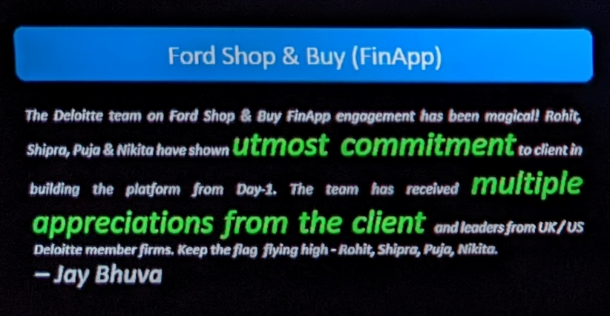 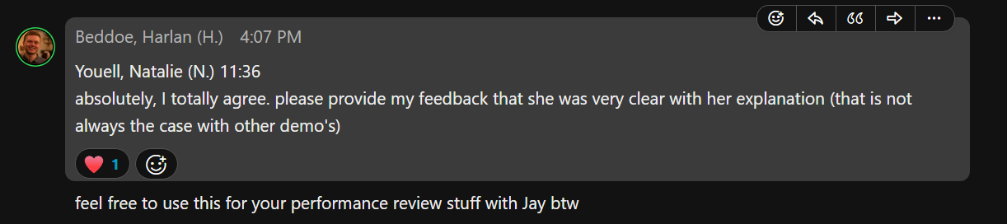

1. Project and Research
   1. Learnt how a proposal is developed
   2. Assisted Associate directors in developing a POC for business

**STRETCH GOALS: GOING THE EXTRA MILE**

1. Mentoring
   1. Provided guidance to Analysts and fellow consultants for navigating through project codebase
   2. Helped Analysts and fellow consultants expand their technical skillset and develop POCs for their learning
   3. Trained them for project-specific skill sets.
2. Contribution to Sales/Support clients/Firm
   1. Proactively developed and maintained relationships at middle management with the current client and teams in UK and USA
   2. Volunteered for firm initiatives (CSR activities)
      1. Created learning material (English Grammar) for secondary school students
      2. Recorded audios (stories) for pre-primary and primary school students on Impact day
   3. Contributed to the community of Practices
      1. Actively creating a community for Front end developers – FEDeration (WIP)

**DEVELOPMENT GOALS**

1. Completed training for
   1. TDD – JEST and React testing library
   2. Package managers – NPM and YARN
   3. CSS frameworks – Tailwind CSS
   4. CSS architecture – Block Element Modifier, BEM (adopted in my current project)
   5. Task runners – Gulp
   6. Module bundlers – Webpack
   7. CI/CD – concepts and Jenkins
2. Training in progress
   1. Automation testing framework – Cypress (Project specific training – additional)
   2. AWS cloud practitioner (development goal)
3. Skipped development goal
   1. CSS framework – ReactStrap
   2. GitHub Actions
4. Upcoming training (to be completed till June)
   1. DSA using JavaScript (rescheduled due to strict project deadlines and releases)
   2. SSR and SSG concepts
   3. Python revision